# CITY OF ARLINGTON

**SIBLEY COUNTY**

**ARLINGTON, MINNESOTA**

**NOTICE OF A SPECIAL CITY COUNCIL MEETING WORKSHOP**

Tuesday, February 20, 2024

7:30 p.m. or immediately following the City Council Meeting

Arlington Water Treatment Plant

101 Henderson Road, Arlington, MN  55307

**Notice is hereby given,** that the Arlington City Council has called a special meeting workshop for   
Tuesday, February 20th at 7:30pm or immediately following the City Council Meeting at the Arlington Water Treatment Plant, 101 Henderson Road, Arlington, MN  55307.

1. A special meeting workshop to tour the Water Treatment Plant.

___________________________

Jessica Steinke, City Administrator

**DATED:** February 6, 2024

**POSTED:** City Hall

Post Office

Library

Website

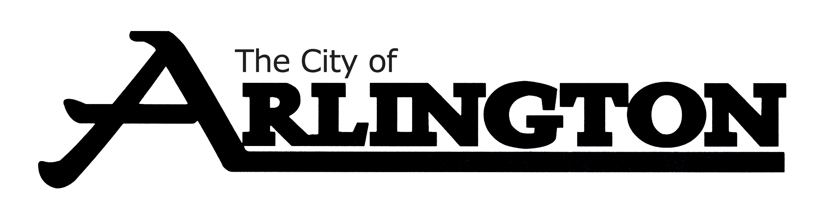

204 Shamrock Drive • Arlington, MN 55307 • 507-964-2378

Fax: 507-964-5973 • www.arlingtonmn.com • cityhall@arlingtonmn.com