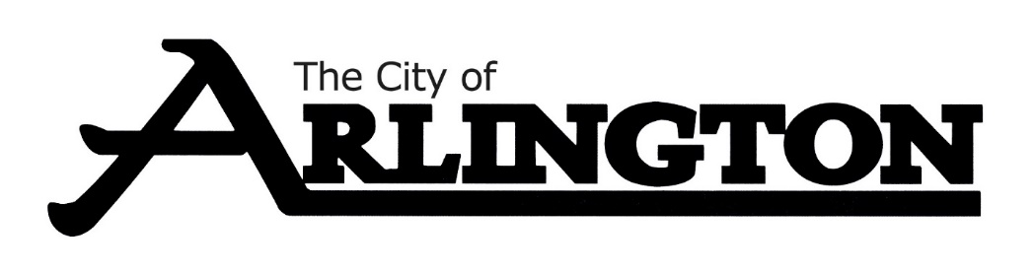
ECONOMIC DEVELOPMENT AUTHORITY
MEETING AGENDA
DECEMBER 7, 2023, AT 5:30 PM
COUNCIL CHAMBERS
Members: Dean Bergersen, Larry Sorenson, Howard Brinkman, Kurt Menk, Tim Kloeckl, Jeff Matz and Curtis Ling
- Call Meeting to Order and Pledge of Allegiance
- Roll Call
- Approve of the Agenda
- Approval of November 2, 2023, Meeting Minutes

OLD BUSINESS
- EDA Land (22-acre parcel), Leah Prahl
- City Lot Update
NEW BUSINESS
- Forgivable Sign Loan Updates
- Daycare Loan
- October Financial Report
MISCELLANEOUS
- Business Updates
ADJOURNMENT

