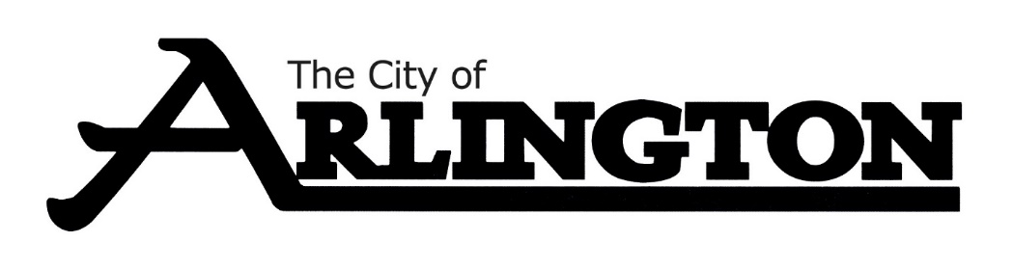
ECONOMIC DEVELOPMENT AUTHORITY
MEETING AGENDA
September 7, 2023, AT 5:30 PM
COUNCIL CHAMBERS
Members: Dean Bergersen, Larry Sorenson, Howard Brinkman, Kurt Menk, Tim Kloeckl, Jeff Matz and Curtis Ling
- Call Meeting to Order and Pledge of Allegiance
- Roll Call
- Approve of the Agenda
- Approval of August 14th, 2023, Meeting Minutes

OLD BUSINESS
- Hoff Property Update, Attorney Lori Moldan
- EDA Land
- Welcome Bags
- EDA Brochures
NEW BUSINESS
- SMIF Presentation
- August Financial Report
- Potential Business Expansion
MISCELLANEOUS
ADJOURNMENT

