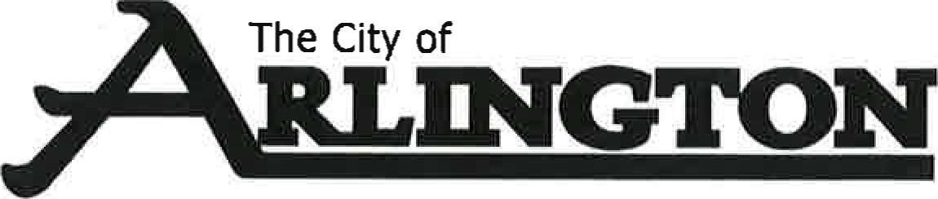
PLANNING AND ZONING COMMITTEE
Meeting Agenda
November 2, 2023, at 7:00 PM
Arlington Event Center — Council Chambers

- Call to Order
- Pledge of Allegiance
- Approve Agenda
- Discussion of potential change at Pit Stop Convenience & Gas Station
- Hwy 5 Complaint
- Adjournment

