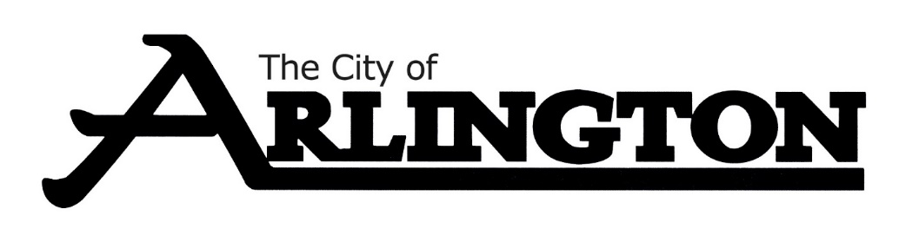
ECONOMIC DEVELOPMENT AUTHORITY
MEETING AGENDA
August 14th, 2023, AT 5:30 PM
COUNCIL CHAMBERS
Members: Dean Bergersen, Larry Sorenson, Howard Brinkman, Kurt Menk, Tim Kloeckl, Jeff Matz and Curtis Ling
- Call Meeting to Order and Pledge of Allegiance
- Roll Call
- Approve of the Agenda
- Approval of July 10th and July 17th, 2023, Meeting Minutes

OLD BUSINESS
- Hoff Property Update, Attorney Lori Moldan (Tentative)
- Potential New Business, County Resources - Christian Lilienthal
- EDA Land
- Business Recognitions Update
NEW BUSINESS
- July Financial Report
- EDA Facebook Page
- Marketing
- Façade Loan Applications
- Moving EDA meetings to Thursdays
MISCELLANEOUS
Social gatherings of city council members will not be considered a meeting subject to the requirements of the open meeting law if there is not a quorum present, or, if a quorum is present, if the quorum does not discuss, decide, or receive information on official city business. The Minnesota Supreme Court has ruled that a conversation between two city council members over lunch about a land-use application did not violate the open meeting law because a quorum of the council was not present.
ADJOURNMENT

