# CITY OF ARLINGTON

**SIBLEY COUNTY**

**ARLINGTON, MINNESOTA**

**NOTICE OF A SPECIAL CITY COUNCIL MEETING WORKSHOP**

Monday, August 21st, 2023

5:30 p.m.

Council Chambers – Arlington Community Center

**Notice is hereby given,** that the Arlington City Council has called a special meeting for   
Monday, August 21st at 5:30pm in the Council Chambers at the Arlington Community Center, 204 Shamrock Drive, Arlington, Minnesota for the following purposes:

1. A special meeting workshop to discuss the 2024 preliminary budget.

___________________________

Jessica Steinke, City Administrator

**DATED:** August 16, 2023

**POSTED:** City Hall

Post Office

Library

Website

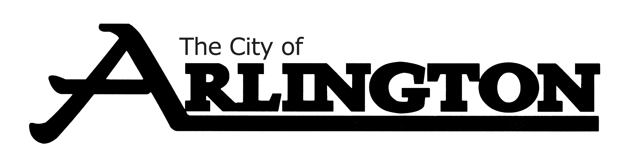

204 Shamrock Drive • Arlington, MN 55307 • 507-964-2378

Fax: 507-964-5973 • www.arlingtonmn.com • cityhall@arlingtonmn.com