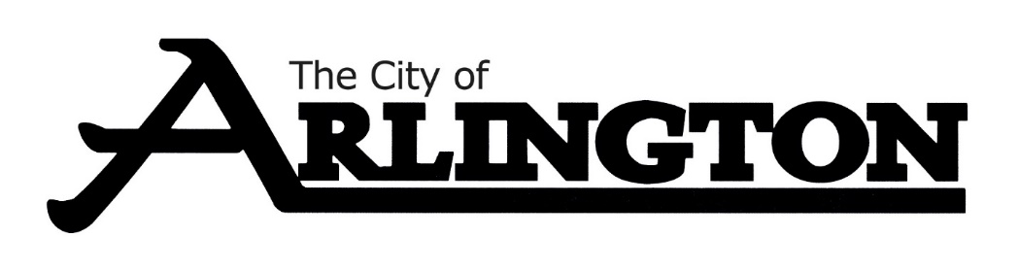
ECONOMIC DEVELOPMENT AUTHORITY
SPECIAL MEETING AGENDA
July 17th, 2023, AT 4:30 PM
COUNCIL CHAMBERS
Members: Dean Bergersen, Larry Sorenson, Howard Brinkman, Kurt Menk, Tim Kloeckl, Jeff Matz and Curtis Ling
- Call Meeting to Order and Pledge of Allegiance
- Roll Call
- Approve of the Agenda

SPECIAL MEETING
- Discuss the property at 23119 411th Avenue, Arlington, MN 55307.
- Discuss the appraisal of the 22-acre EDA property on Hwy 5 in Arlington, MN
- Discuss EDA Programs and Materials
- Discuss Business Recognition
ADJOURNMENT

