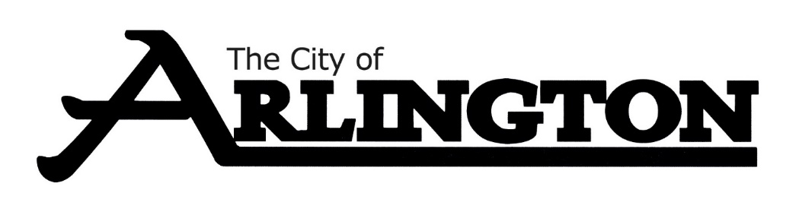
ECONOMIC DEVELOPMENT AUTHORITY
MEETING AGENDA
July 10th, 2023, AT 5:30 PM
COUNCIL CHAMBERS
Members: Dean Bergersen, Larry Sorenson, Howard Brinkman, Kurt Menk, Tim Kloeckl, Jeff Matz and Curtis Ling
- Call Meeting to Order and Pledge of Allegiance
- Roll Call
- Approve of the Agenda
- Approval of June 12, 2023, Meeting Minutes

OLD BUSINESS
- Hoff Property Update, Attorney Janssen
- EDA Land Appraisal
NEW BUSINESS
- Potential New Business, Christian Lilienthal
- Discussion on Current Programs and Brochures
- Business Recognitions
MISCELLANEOUS
ADJOURNMENT

