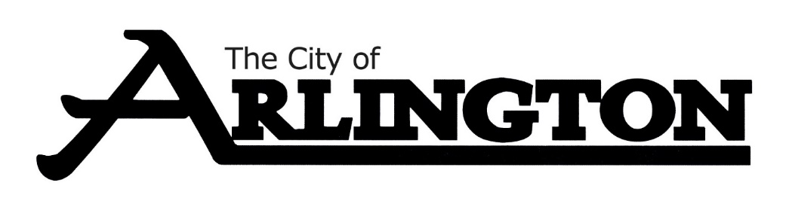
ECONOMIC DEVELOPMENT AUTHORITY
MEETING AGENDA
JUNE 12, 2023, AT 5:30 PM
COUNCIL CHAMBERS
Members: Dean Bergersen, Larry Sorenson, Howard Brinkman, Kurt Menk, Tim Kloeckl, Jeff Matz and Curtis Ling
- Call Meeting to Order and Pledge of Allegiance
- Roll Call
- Approve of the Agenda
- Approval of May 8, 2023, Meeting Minutes

OLD BUSINESS
- Amba Homes Update
- Seneca/Data Metal Craft Update
- Review of Financial Reports for April of 2023
- Hoff Property Update
NEW BUSINESS
MISCELLANEOUS
ADJOURNMENT

