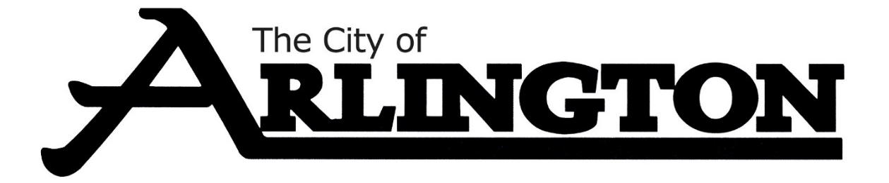
SPECIAL MEETING AGENDA
June 13, 2023, AT 5:30 PM
COUNCIL CHAMBERS

- Call Meeting to Order and Pledge of Allegiance
- Roll Call
- Approval of the Agenda

CLOSE MEETING
- Discuss threatened litigation regarding the property at 23119 411th Avenue, Arlington, MN 55307.

OPEN MEETING

- Adjournment

