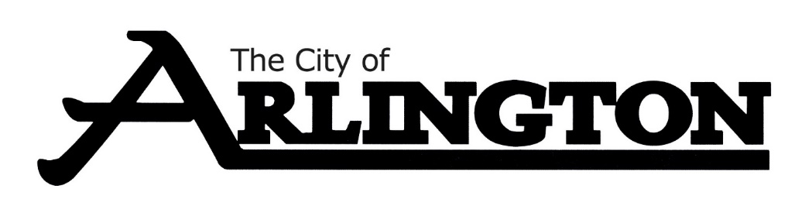
ECONOMIC DEVELOPMENT AUTHORITY
MEETING AGENDA
MAY 8, 2023, AT 5:30 PM
COUNCIL CHAMBERS
Members: Dean Bergersen, Larry Sorenson, Howard Brinkman, Kurt Menk, Tim Kloeckl, Jeff Matz and Curtis Ling
- Call Meeting to Order and Pledge of Allegiance
- Roll Call
- Approve of the Agenda
- Approval of April 10, 2023, Meeting Minutes

OLD BUSINESS
- Update on easement request from Middle Mile Infrastructure
- Public Hearing
  - The purpose of this hearing is to consider the easement request made by Middle Mile Infrastructure to build an Integrated Line Amplifier Station (ILA) on the lot legally described as TRACT 1 OF NW 1/4 SURV 692, Sibley County PID 31.0884.000. This lot is owned by the City of Arlington’s Economic Development Authority.
- Amba Homes Update
- Seneca/Data Metal Craft Update
- EDA Budget Update
- Review of Financial Reports for February and March of 2023
NEW BUSINESS
MISCELLANEOUS
ADJOURNMENT

