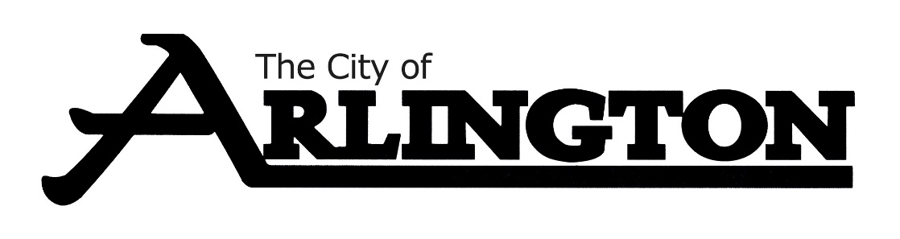
ARLINGTON EVENT CENTER
MEETING AGENDA
MAY 11, 2023, AT 5:30 PM
COUNCIL CHAMBERS
- Call Meeting to Order with Pledge of Allegiance

- Roll Call

- Approve the Agenda

- Approve the Meeting Minutes from March 9, 2023

- Sound System Update

- Event Center Cleaning Update

- Building Keys Update

- Review of Policy Handbook to include bringing in outside equipment

- Miscellaneous

- Adjournment

Next Meeting will be held on Thursday August 10, 2023, at 5:30 pm.

