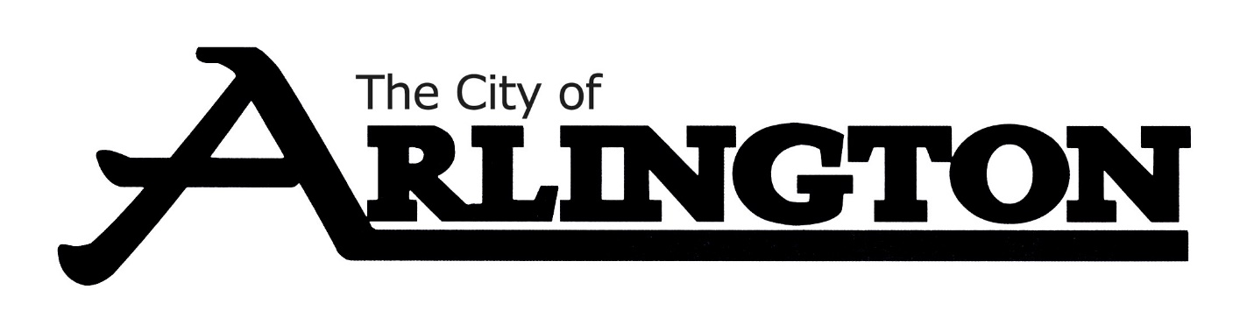
PARKS COMMITTEE
MEETING AGENDA
APRIL 24, 2023, at 7:00 PM
Arlington Event Center- Council Chambers
Arlington, MN 55307
- Call Meeting to Order

- Pledge of Allegiance

- Roll Call

- Approve Agenda

- Approve Meeting Minutes from April 25, 2022

- Buck’s Plaque at Sportsman’s Park-Move Location

- Review of 2022 Budget and year to date spending

- Review of Discussion on the Basketball Courts

- Budgeting for Parks (Moving Forward)

- Maintenance Supervisor Update-Parks Condition

- Plans for the Summer

- Open Discussion

- Adjourn

Next Meeting-July 24 at 7:00 pm

