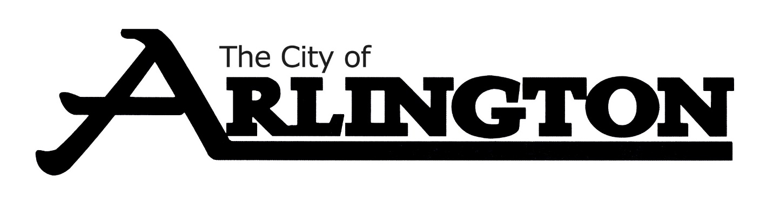
CEMETERY COMMITTEE
MEETING AGENDA
APRIL 24, 2023, at 6:00 PM
Arlington Event Center- Council Chambers
Arlington, MN 55307
- Call Meeting to Order

- Pledge of Allegiance

- Roll Call

- Approve Agenda

- Approve Meeting Minutes from April 25, 2022

- Review of 2022 Budget and Year to Date Spending

- Open Discussion

- Adjourn

Next Meeting-July 24 at 6:00 pm

