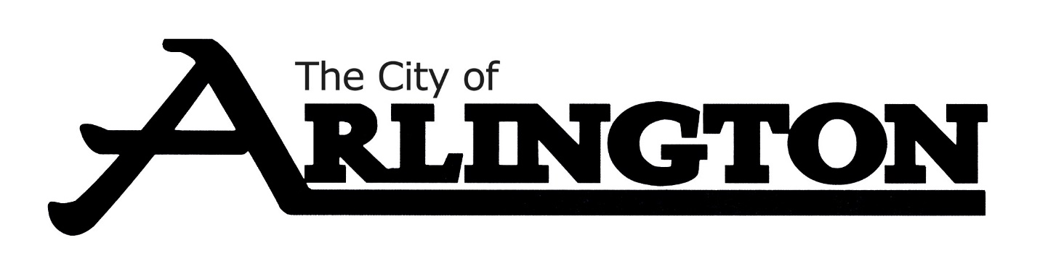
PERSONNEL/EMPLOYEE RELATIONS COMMITTEE
MEETING AGENDA
MARCH 16, 2023 @ 5:30 P.M.
Arlington Community Center—Council Chambers
Arlington, MN 55307

- Call Meeting to Order

- Roll Call

- Discussion on Job Description and Duties

- Fire Chief Doug Mackenthun regarding Interview Process and Fire Dept. Officers

- Review of Complaint against Councilman Thomes

- City Attorney Janssen’s presentation of City Code of Ethics

- Discussion on Conflict of Interest

- Adjourn

