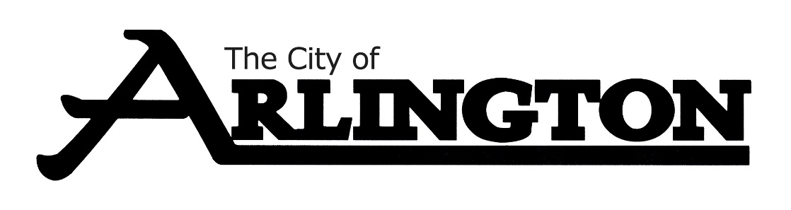
EVENT CENTER COMMITTEE
MEETING AGENDA
December 8, 2022, AT 5:30 P.M.
City Council Chambers

- Call to Order/Pledge of Allegiance

- Approve the Agenda

,
- Approve the Meeting Minutes from August 18, 2022

- Discussion on Event Center Cleaning

- Discussion on Liquor Service

- Review of Policy Book

- Miscellaneous

- Adjourn

