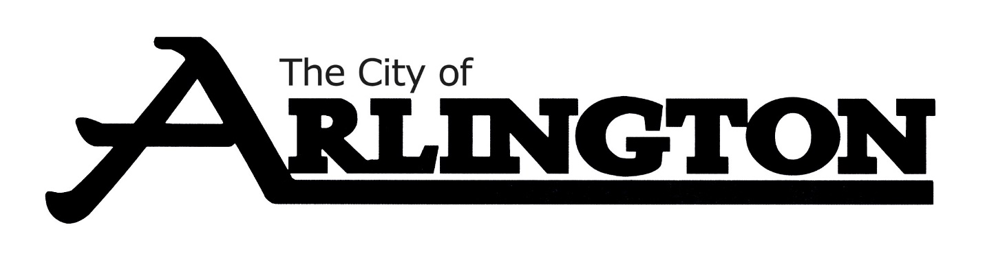
ARLINGTON COMMUNITY CENTER
MEETING AGENDA
August 11, 2022 at 5:30 PM
Arlington Community Center-Council Chambers

- Call to Order/ Pledge of Allegiance

- Approve Agenda

- Discussion on Hiring a Cleaning Crew

- Discussion on Attendant Applications

- Discussion about the Budget

- Other Business

- Discussion on Name Change

- Discussion on Indoor Pickleball

- Discussion on Raising Damage Deposit

- Discussion on Outside Alcohol Providers

- Adjournment

