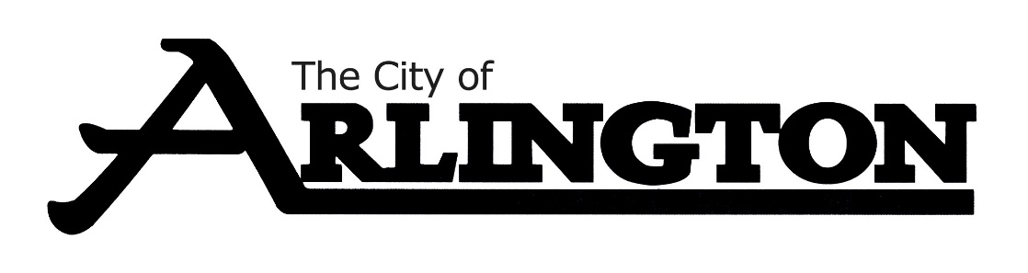
ARLINGTON EVENT CENTER
MEETING AGENDA
MARCH 9, 2023, AT 5:30 PM
COUNCIL CHAMBERS
- Call Meeting to Order

- Roll Call

- Approve the Agenda

- Approve the Meeting Minutes from December 8, 2022

- Event Center Tour

- Event Center Cleaning Update

- Building Keys Update

- ATM Information Update

- Miscellaneous

- Adjournment

Next Meeting will be held on Thursday May 11, 2023 at 5:30 pm.

