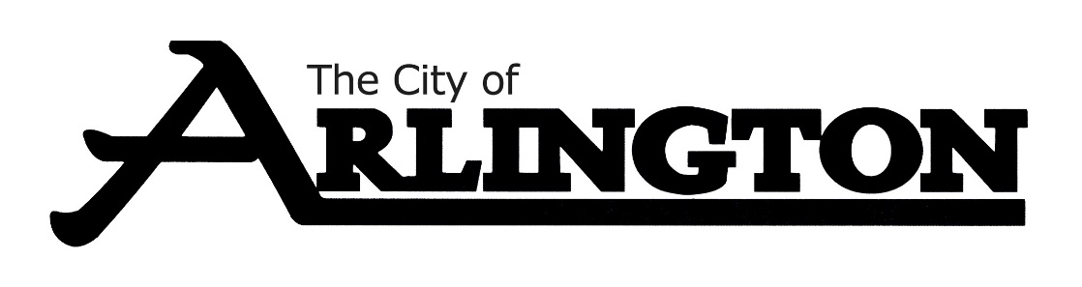
ARLINGTON CITY COUNCIL
WORKSHOP AGENDA
March 21, 2023, AT 5:30 PM
COUNCIL CHAMBERS

- Call Meeting to Order

- Roll Call

- Pavement Management Plan

- Public Works CIP Budget-update

- Adjournment.

