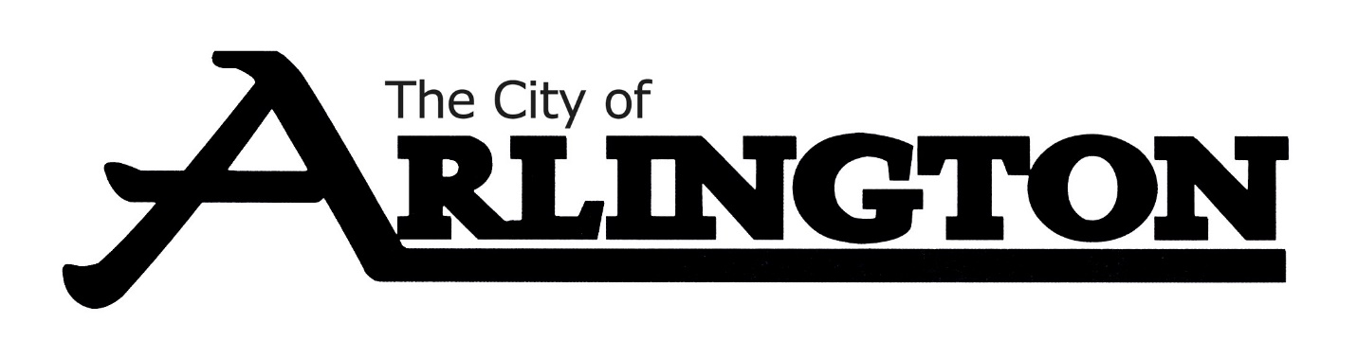
ARLINGTON CITY COUNCIL
SPECIAL MEETING AGENDA
MARCH 7, 2023, AT 10:00 AM
ARLINGTON EVENT CENTER
Council Chambers

Interviews will include the full City Council; it will be an open meeting and the public may be in attendance.

- Call Meeting to Order and Pledge of Allegiance

- City Administrator Interviews:
  - 10:00-10:45 AM- Richard Baker

  - 11:00-11:45 AM- Jessica Steinke

  - 12:00-1:00 PM- Break for Lunch

  - 1:15-2:00 PM- Jeffrey Cielocha

- 3:15 PM- Council goes into a closed session to discuss parameters for contract and to decide on who they will choose as new City Administrator.

- Adjournment

