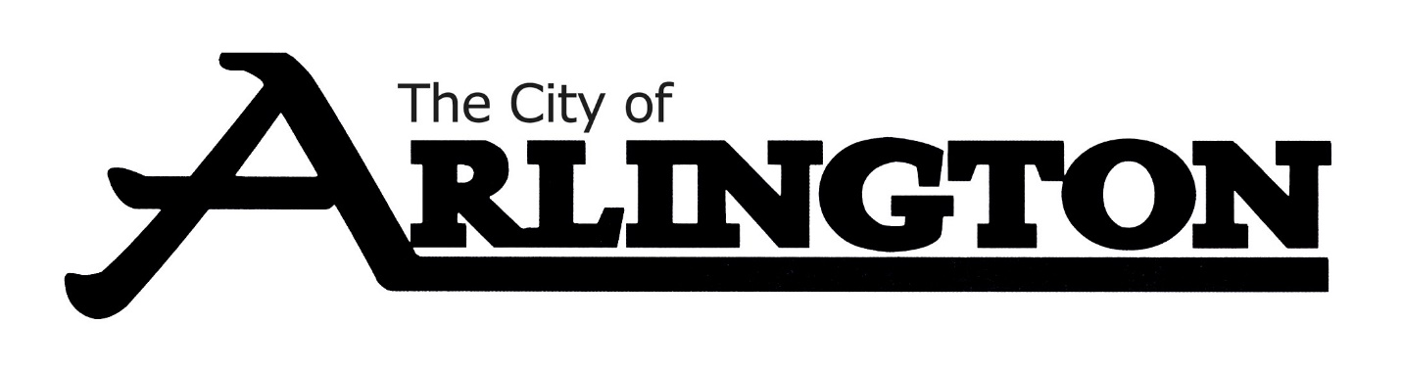
Continuation of Special Meeting
March 7, 2023
- Summary Statement of Closed Meeting of 3-7-2023- Councilman Thomes made a motion to offer a contract for City Administrator to Jessica Steinke. Councilman Matz seconded. Motion carried.
Councilman Meyer made a motion to offer $98,000 to Jessica Steinke. Councilman Thomes seconded. Motion carried.

- Motion to Adjourn

ARLINGTON CITY COUNCIL
MEETING AGENDA
March 20, 2023, AT 6:30 PM
COUNCIL CHAMBERS
The City Council is provided background information for agenda items in advance by city staff, committees, and boards. Many decisions regarding agenda items are based upon this information, as well as: City policy and practices, input from constituents, questions or information that has not yet been presented or discussed regarding an agenda item. If you have a concern or question, please ask to be recognized by the Mayor during the “Citizens addressing the Council” portion of the agenda- state your name and address for the record. Please keep comments under 5 minutes. Individuals wishing to speak for more than five minutes should ask to be included on the agenda in advance. All comments are appreciated, but please refrain from personal or derogatory attacks on individual.
- Call Meeting to Order and Pledge of Allegiance

- Roll Call

- Approve the Agenda and any Agenda Additions

- Citizens Addressing the Council

CONSENT AGENDA

- Approval of Consent Agenda
- Approval of Bills
- December 8, 2022, Event Center Meeting Minutes
- February 13, 2023, EDA Meeting Minutes
- March 6, 2023, City Council Meeting Minutes

PETITIONS, REQUESTS & COMMUNICATIONS

- March 9, 2023, Event Center Meeting Minutes-Unapproved

- Withdraw of EDA Childcare Loan Application from Gwen Scharpe

REPORTS OF OFFICERS, BOARDS AND COMMITTEES

- February Fire Department Report- Fire Chief Doug Mackenthun

- February Police Department Report-Police Chief Glenn Gerads

- Approval of six-month review of Officer Brandon Legg and pay increase to $27/hr

- February People Service Report

- Approve LED lighting quote from The Retrofit Companies in the amount of $4000 for the Wastewater Treatment Facility for Lighting Upgrade

- Interim City Administrator Update- Shirley Slater-Schulte

- Approval of extra hours worked

- Review of Finance Position/Update on Job Description

- Attorney Janssen Update

- Code of Ethics Presentation

ORDINANCES AND RESOLUTIONS
- Approve Resolution 13-2023 A RESOLUTION APPROVING STATE OF MINNESOTA JOINT POWERS AGREEMENTS WITH THE CITY OF ARLINGTON ON BEHALF OF ITS CITY ATTTORNEY AND POLICE DEPARTMENT

- Approve Resolution 14-2023 A RESOLUTION APPOINTING CITY ADMINISTRATOR AND AUTHORIZING THE CITY OF ARLINGTON TO ENTER INTO A CONTRACT WITH JESSICA STEINKE

- Approve Resolution 15-2023 A RESOLUTION WITHDRAWING THE REQUEST FOR A LOAN TO GWEN SCHARPE FROM THE ARLINGTON EDA CHILD CARE LOAN PROGRAM

UNFINISHED BUSINESS

NEW BUSINESS

- Approve recommendation to hire SafeBasements of Minnesota Inc. to complete basement work at the Arlington Library for $10,500.

- Innovative Basement Authority- $24,786.34
- SafeBasements of Minnesota Inc- $10,500.00

- Approve Purchase of JRB416 Hitch with Bolt on Plate Attachment for New Snowblower to Attach to Current Loader at $4125

- Personnel Committee’s Determination on Citizen’s Complaint against Councilman Thomes

- Closed Session-Citizen’s Complaint against Interim City Administrator Shirley Slater-Schulte

- Re-open Meeting

MISCELLANEOUS BUSINESS

ADJOURNMENT

Reminders:
March 21 at 5:30 pm-Council Workshop
March 29 at 6:30 pm-Fire Relief
April 3 at 6:30 pm-Council Meeting
April 6 at 7 pm-P & Z Meeting

