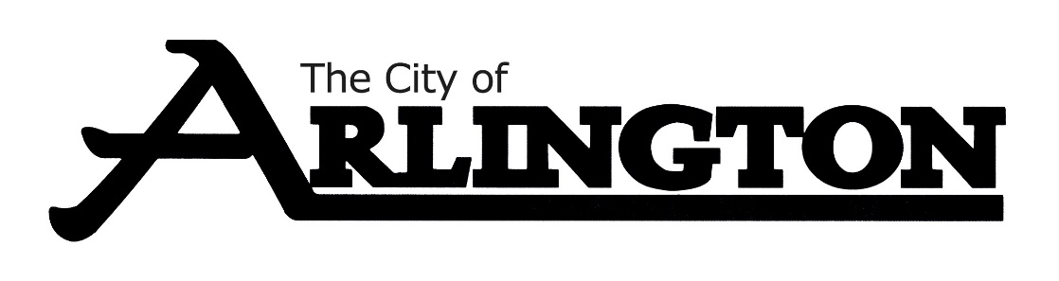
ARLINGTON CITY COUNCIL
MEETING AGENDA
June 6, 2022, AT 6:30 PM
COUNCIL CHAMBERS

The City Council is provided background information for agenda items in advance by city staff, committees, and boards. Many decisions regarding agenda items are based upon this information, as well as: City policy and practices, input from constituents, questions or information that has not yet been presented or discussed regarding an agenda item. If you have a concern or question, please ask to be recognized by the Mayor during the “Citizens addressing the Council” portion of the agenda- state your name and address for the record. Please keep comments under 5 minutes. Individuals wishing to speak for more than five minutes should ask to be included on the agenda in advance. All comments are appreciated, but please refrain from personal or derogatory attacks on individual.

- Call Meeting to Order and Pledge of Allegiance

- Roll Call

- Approve the Agenda and any Agenda Additions

- Addressing the Council

CONSENT AGENDA
- Approval of Consent Agenda
A) Approval of Bills
B) May 16, 2022 City Council Minutes
C) May 19, 2022 City Council Special Meeting Minutes
D) Approve hiring of Hattie Jenkins as a .6 EMT with the Arlington Area Ambulance

PETITIONS, REQUESTS & COMMUNICATIONS
- Presentation by Southern Minnesota Initiative Foundation (SMIF), Alissa Oeltjenbruns

- MMPA Board Meeting Public Summary May 2022

- MMPA Energy Adjustment Clause for June 2022

- Resignation of Ryan Benjamin from the Arlington Fire Department

REPORTS OF OFFICERS, BOARDS AND COMMITTEES
- June Public Works Department- Public Works Supervisor Kirby Weckworth
- Sidewalk replacement (Zoning Administrator Phil Mangis)
- CMC $49,995
- Wenzlaff Masonry-$54,540

- Ambulance Department Report – Ambulance Manager Jamie Weikle
- Request to rescind resignation of Ambulance Member Kevin Hesse

- Electrical Engineer Annual Report from Sarah Peterson MVEC

- 2021 Parks Committee Annual Report- Al Ihrke, Chair

ORDINANCES AND RESOLUTIONS
- Approve/deny resolution 37-2022 AN RESOLUTION ACCEPTING A DONATION AND DESIGNATING ITS USE

- Approve/deny resolution 38-2022 A RESOLUTION CALLING PUBLIC HEARING ON THE ESTABLISHMENT OF TAX INCREMENT FINANCING DISTRICT NO. 1-4 WITHIN MUNICIPAL DEVELOPMENT DISTRICT NO. 1 AND THE ADOPTION OF A TAX INCREMENT FINANCING PLAN RELATING THERETO
UNFINISHED BUSINESS
- Request for funding for SE tennis courts (tabled 5-16-2022)

NEW BUSINESS
- 2021 Final Audit Presentation by Tom Olinger, ABDO

- Update on Water Treatment Facility Rehabilitation from Jake Pichelmann of Bolten & Menk

- Request by Lindsay Sjostrom to add business parking only to South side of West Alden Street by S & F Enterprises building

- Update on Seneca Trailer Park

- Approve/Deny Load Shedding Policy

- Discussion on transition of Library back to the City

- Approve/Deny Library Director and Library Assistant Job Descriptions

- Discussion on paperless City Newsletter

- Update on meeting with Northland Drying Attorney

- Consider removing administrative permit process

MISCELLANEOUS BUSINESS
Committee Updates

Open discussion
ADJOURNMENT

Reminders:
June 13- EDA Meeting at 5:30pm
June 20-City Council Budget Workshop at 5:30pm
June 20-City Council Meeting at 6:30pm

