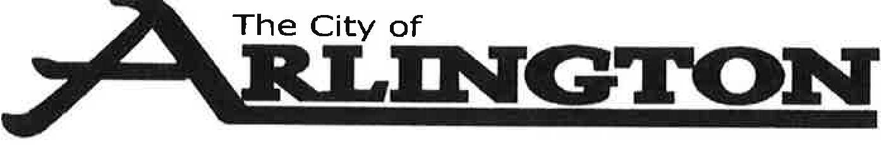

ECONOMIC DEVELOPMENT AUTHORITY MEETING AGENDA

January 9, 2023 @5:30 P.M.
Arlington Community Center - Council Chambers

- Call to Order

- Pledge of Allegiance

- Approval of Agenda

- Approval of Minutes
- December 12, 2022

- Approval of Reports
- December Financial Report

- New Business
- 2022 Annual Report
- Connect Business Magazine
- 2023 Fee Schedule

- Old Business
- Nuvera Fiber

- EDA Director update on businesses and housing
- Business visits and Facebook page

- P&Z Update

- Director and Board Comments

- Adjourn

