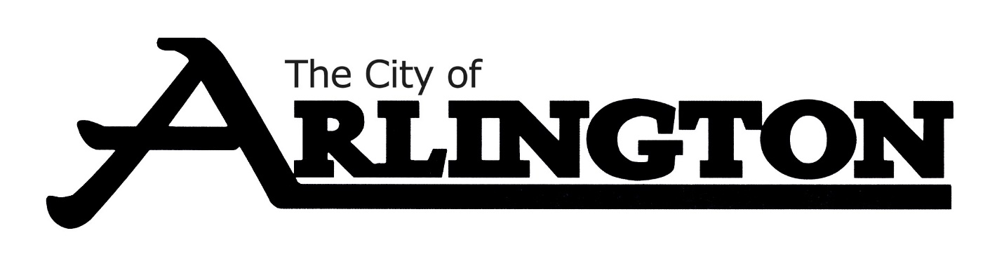
ARLINGTON CITY COUNCIL
WORKSHOP MEETING AGENDA
December 5, 2022 at 5:30 P.M.
COUNCIL CHAMBERS

- Call Meeting to Order

- Roll Call

- Presentation by Nuvera

- Adjournment

