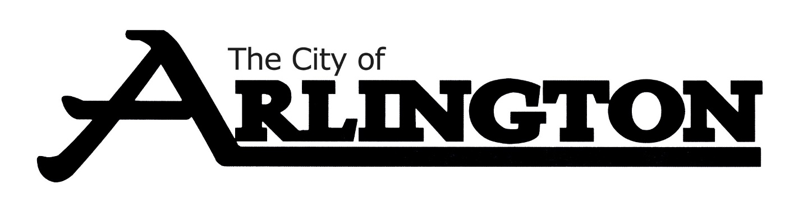
CITY COUNCIL SPECIAL CANVASSING
MEETING AGENDA
November 14, 2022 @ 6:30 P.M.
Arlington Community Center—Council Chambers

- Call Meeting to Order

- Approve Resolution 65-2022 A RESOLUTION CANVASSING ELECTION RESULTS

- Adjourn

