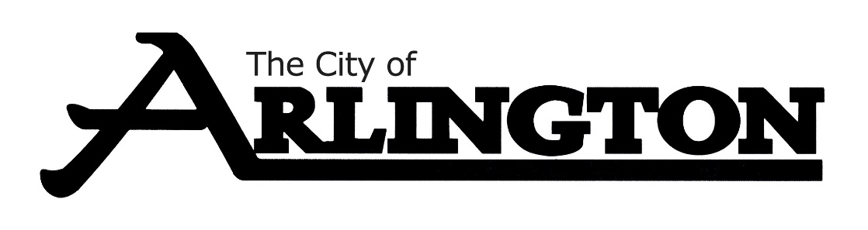
ARLINGTON CITY COUNCIL
WORKSHOP AGENDA
September 6, 2022, AT 5:30 PM
COUNCIL CHAMBERS

- Call Meeting to Order

- Roll Call

- Review of Preliminary Budget

- Adjournment

