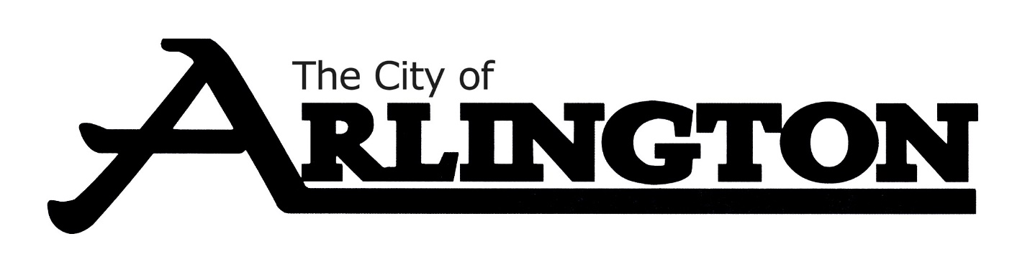
ARLINGTON CITY COUNCIL
WORKSHOP MEETING AGENDA
August 15, 2022 at 5:30 P.M.
COUNCIL CHAMBERS

- Call Meeting to Order

- Roll Call

- Working on Preliminary Levy

- Adjournment

