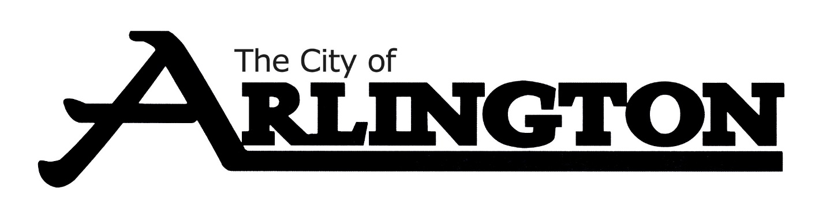
ARLINGTON CITY COUNCIL
WORKSHOP MEETING AGENDA
August 1, 2022 at 5:30 P.M.
COUNCIL CHAMBERS

- Call Meeting to Order

- Roll Call

- Discussion on Sibley East Pool

- Discussion on Operating Budget

- Adjournment

