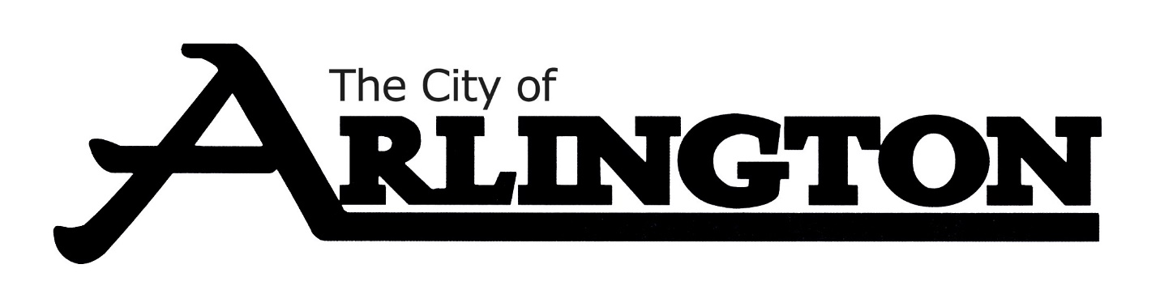
ARLINGTON CITY COUNCIL
WORKSHOP MEETING AGENDA
July 18, 2022 at 5:30 P.M.
COUNCIL CHAMBERS

- Call Meeting to Order

- Roll Call

- Discussion on CIP Budget

- Discussion on Operating Budget

- Adjourn

