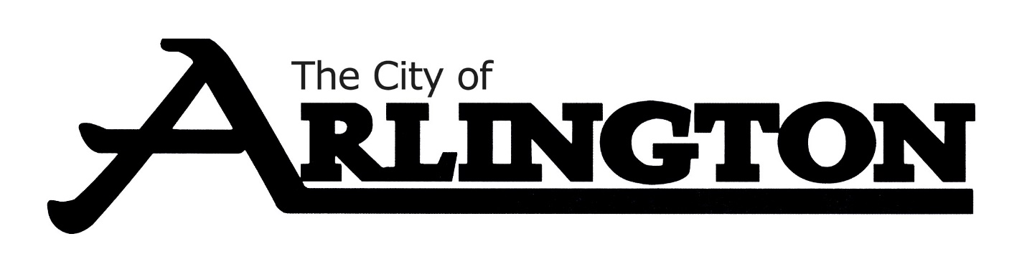
ARLINGTON CITY COUNCIL
MEETING AGENDA
Monday, June 20, 2022, AT 6:30 PM
Council Chambers
The City Council is provided background information for agenda items in advance by city staff, committees, and boards. Many decisions regarding agenda items are based upon this information, as well as: City policy and practices, input from constituents, questions or information that has not yet been presented or discussed regarding an agenda item. If you have a concern or question, please ask to be recognized by the Mayor during the “Citizens addressing the Council” portion of the agenda- state your name and address for the record. Please keep comments under 5 minutes. Individuals wishing to speak for more than five minutes should ask to be included on the agenda in advance. All comments are appreciated, but please refrain from personal or derogatory attacks on individual.
- Call meeting to order

- Roll Call

- Approve the Agenda

- Addressing the Council

CONSENT AGENDA
- Approval of Consent Agenda

- Approval of Bills
- June 6, 2022 City Council Minutes
- Kelso Agreement
- Approve the hiring of Breanna Bardwell as .6 FTE with Arlington Area Ambulance

PETITIONS, REQUESTS AND COMMUNICATIONS

- Announcements
- Communication
REPORTS OF OFFICERS, BOARDS AND COMMITTEES
- Fire Department Report
- Approve/Deny AFD Standard Operating Guidelines
- Police Department Report
- Planning and Zoning Report
- People Service Report-May O&M Report
- Review Revenue & Expenditure Summaries
- Building Permit Reports Jan-May 2022

ORDINANCES AND RESOLUTIONS
- Resolution 39-2022 A RESOLUTION ACCEPTING A DONATION AND DESIGNATING ITS USE
- Resolution 40-2022 A RESOLUTION APPOINTING ELECTION JUDGES FOR THE 2022 ELECTIONS
- Resolution 41-2022 A RESOLUTION APPROVING THE APPLIATION FOR A LAWFUL GAMBLING PERMIT FOR ARLINGTON FIRE RELIEF ASSOCIATION

UNFINISHED BUSINESS

NEW BUSINESS

MISCELLANEOUS BUSINESS
Committee Updates

Open Discussion
ADJOURNMENT

Reminders
June 27- Parks Committee-Parks tours at 5:15pm
July 5-Council Budget Workshop at 5:30pm
July 5- City Council Meeting at 6:30pm
July 7- Planning and Zoning meeting at 7pm
July 11-EDA meeting at 5:30pm
July 18-Council Budget Workshop at 5:30pm
July 18- City Council Meeting at 6:30pm
July 25-Cemetery Committee meeting at 6pm

