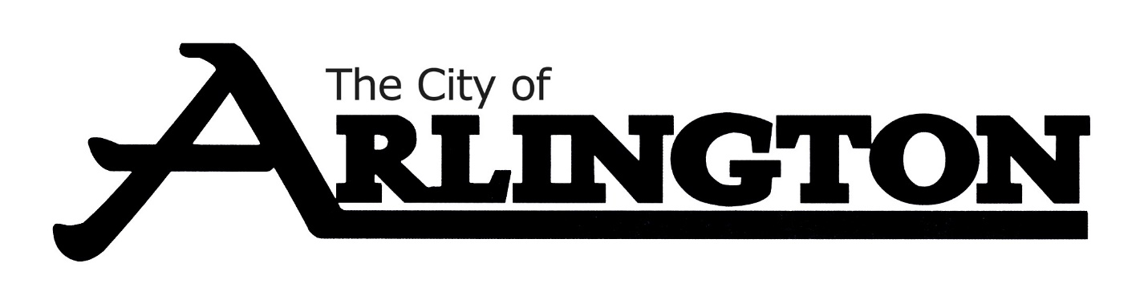
ARLINGTON CITY COUNCIL
SPECIAL MEETING AGENDA
MAY 19, 2022, AT 5:30 PM
ARLINGTON COMMUNITY CENTER

Interviews will include the full City Council; it will be an open meeting and the public may be in attendance.

- Call Meeting to Order and Pledge of Allegiance

- Police Chief Interviews:
  - 5:30pm-Glenn Gerads

  - 6:30pm-Jeremy Lerfald

- Discussion

- Adjournment

